8/16/18 Training - Radiogram Helper

Radiogram Helper - - -

When I first got started originating Radiograms, I made a bunch of mistakes of not using the prowords “Initial(s)”, “Figure(s)”, “Mixed Group”, “Number Group”, “Letter Group”, etc.  So, after I wrote the message, I put little initials (I, F, MG, NG, LG, etc.) by each applicable word (or group) to remind me to use the correct prowords when sending the message.

So (in the example below), the TEXT would be sent as - - -

**INITIALS** ALPHA ROMEO LIMA      FIFTY I SPELL FOXTROT INDIA FOXTROT TANGO YANKEE      AND      THANKS      FOR I SPELL FOXTROT OSCAR ROMEO      CHECKING      INTO      THE      WAYNE I SPELL WHISKY ALPHA YANKEE NOVEMBER ECHO    PIKE I SPELL PAPA INDIA KILO ECHO                                            **INITIALS** ALPHA ROMEO ECHO SIERRA      NET      ON      THE      **MIXED GROUP** ONE FOUR SIX ROMEO SEVEN ONE FIFE      REPEATER      WITH                    **INITIAL** ALPHA      **INITIALS** PAPA LIMA      OF I SPELL OSCAR FOXTROT      **MIXED GROUP** EIGHT TWO ROMEO FIFE    **INITIALS** HOTEL ZULU    **INITIAL** X-RAY    **FIGURES** SEVEN THREE

This simple step really improved my Radiogram “skills”… and the more Radiograms I originated, the more I didn’t need to put the reminder initials in.

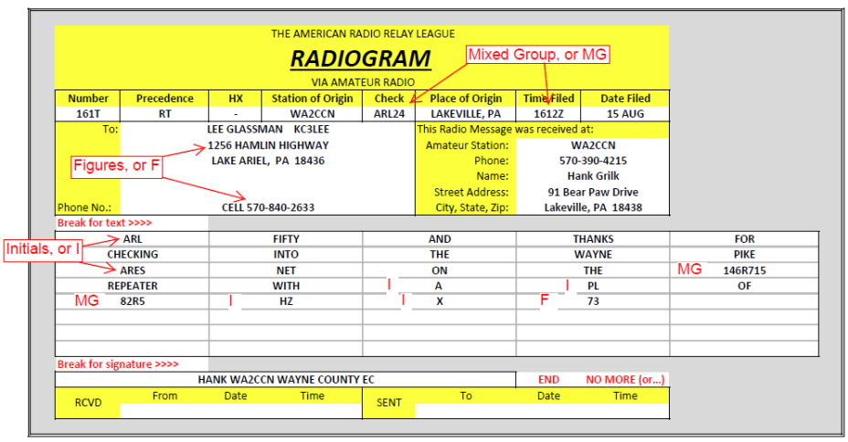

Here’s how I would write a Radiogam…

